***Java & Internet Settings for Oracle Application***

1. Install and configure latest Java version (must be version 8 update 77) if old then overwrite
2. Add production and development server’s entries in system host file
3. Internet security settings (Client)
4. **Download and Install latest Java from AL-Gihaz Portal URL:**

Type in browser <https://portal.algihaz.com> (external/through internet) or <http://portal> (internal/LAN connection)

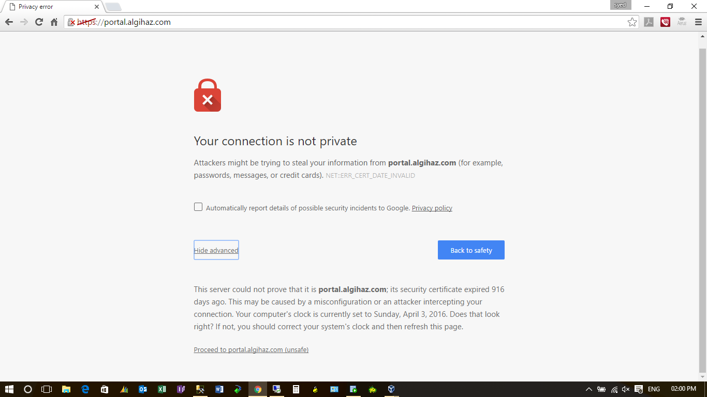

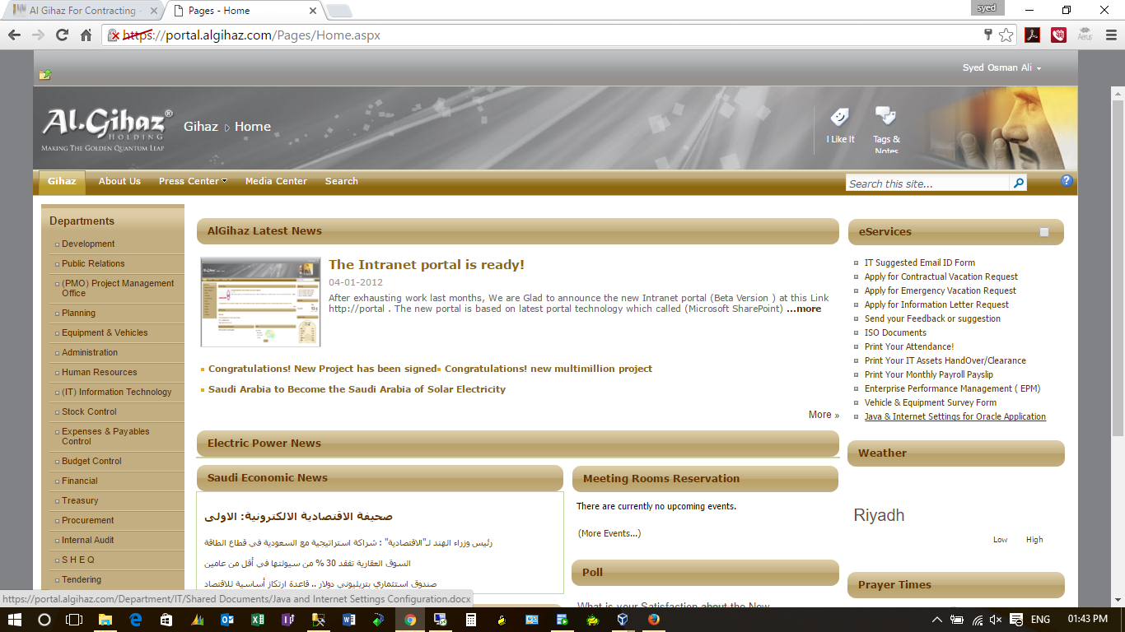

Double click on below Image and Save Java file to PC and run following file:



**Steps to install Java:**

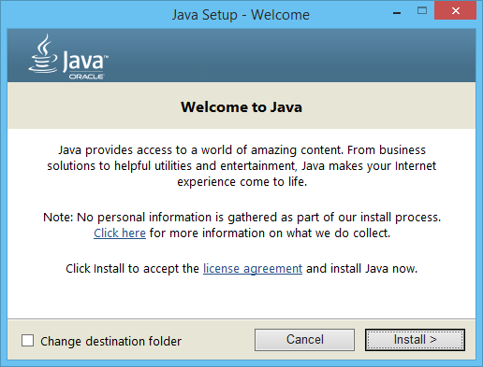

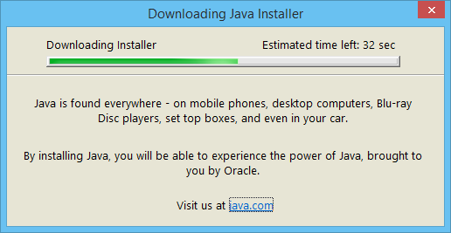

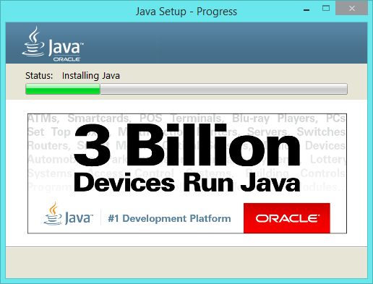

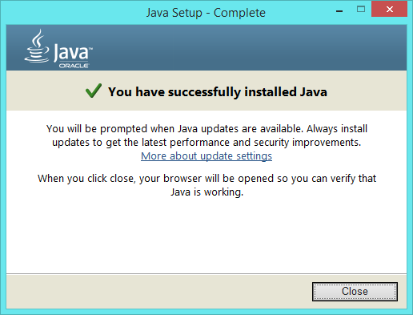

**After Installing Java, security settings required for sites:**

First open Java from control panel

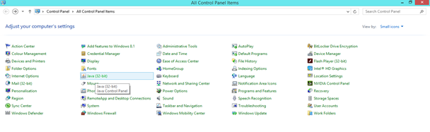

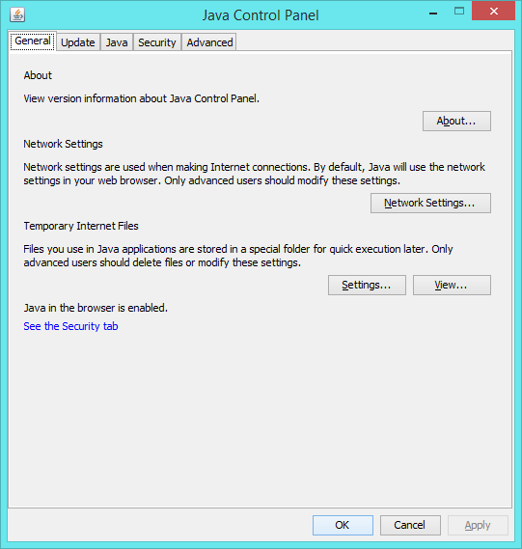

Go to security tab and add prod and dev servers sites by clicking on Edit Site List..

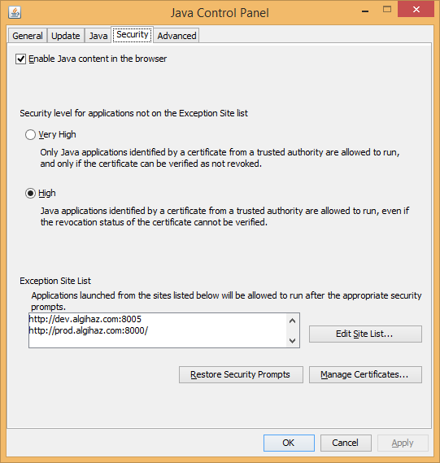

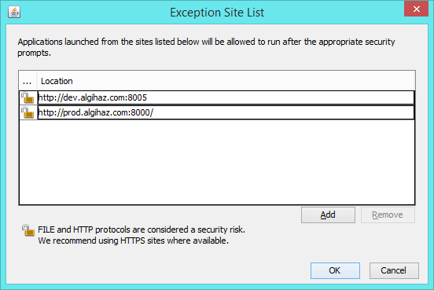

<http://dev.algihaz.com:8005>

<http://prod.algihaz.com:8000>

Press add then ok.

1. **After Installing java add entries for production and development in system host file:**

Go to folder path: C:\Windows\System32\drivers\etc

Open Hosts file

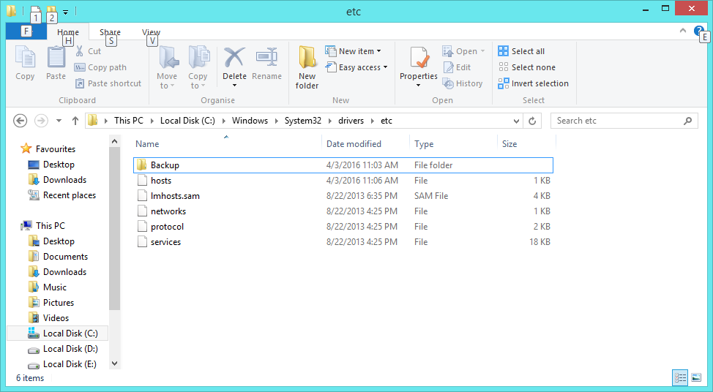

Add following enteries in host file

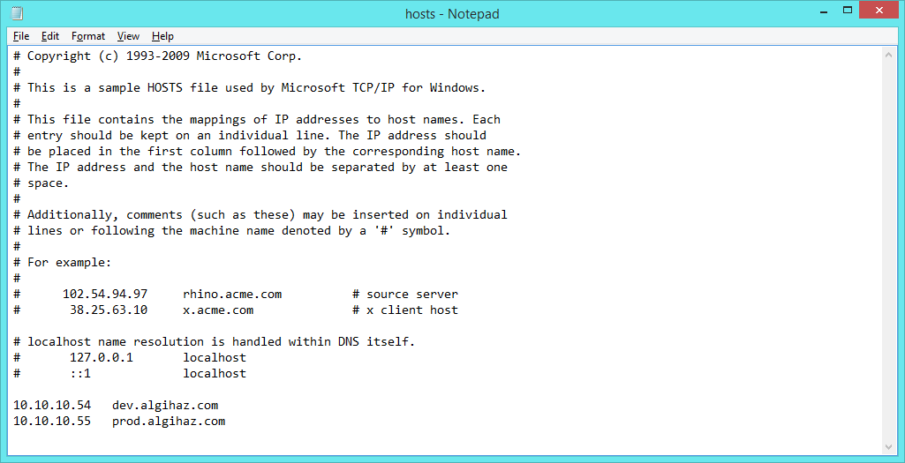

If problem is saving then save hosts file in other drive and again replace it in C:\Windows\System32\drivers\etc folder

1. **Open internet explorer and change security settings**

Open internet explorer and type URL:

<http://prod.algihaz.com:8000/>

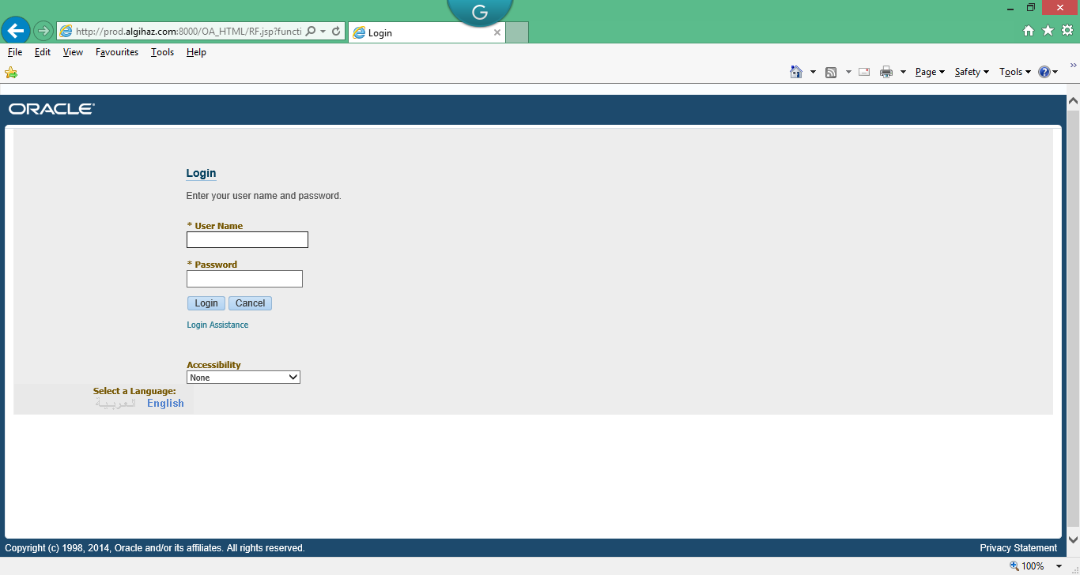

Go to tools and internet options

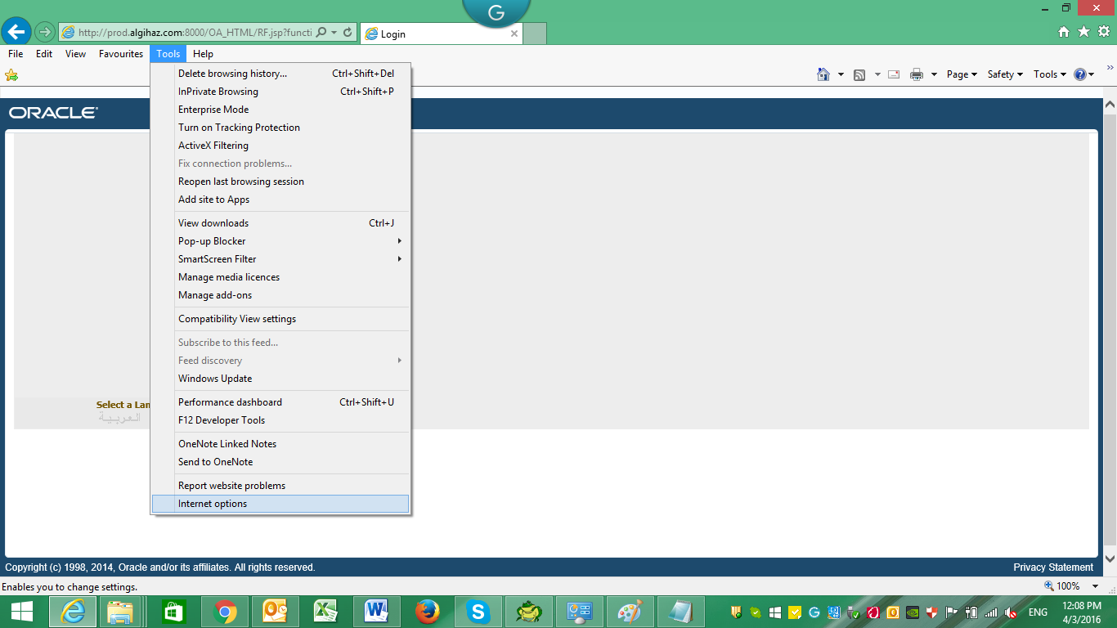

Then go to the security tab and select on trusted sites and click sites

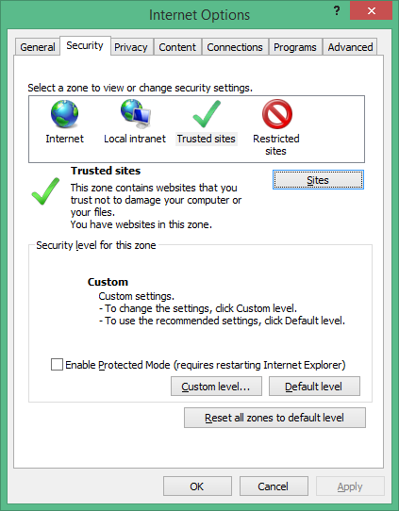

Add both prod and dev server’s URL and uncheck require server verification

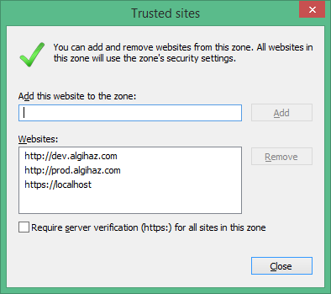

Click close

Application URL:

<http://prod.algihaz.com:8000/>

Login with your given UserName & Password

When you open application responsibility Java message appear

Check on “ I accept the risk and want to run this application”

